Name: _poorab gangwani_________________

Section: ____2B_____________

Enrollment #: __cs191092___________

**LAB # 2**

**Introduction to Measuring Methods of Resistance**

**Lab Objectives:**

* To learn how to read a Resistor’s Resistance using its Color Codes.

**PRE-LAB:**

1. **Introduction to Resistor Color Codes**:

Each resistor has various color bands, which indicate the resistance of that particular resistor. These color bands are classified as digit bands, multiplier band and the tolerance band. The table along with the example given below, show how to calculate a resistor’s resistance.

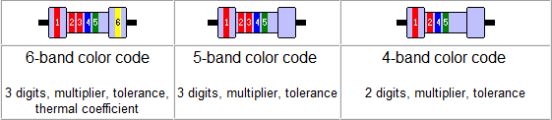

*Fig. 2.1: Type of resistor bands*

The tolerance band indicates the resistor’s percentage deviation from the resistance value indicated by its color bands. For example, a 47 kΩ resistor having a tolerance of ± 10%, may have its actual resistance anywhere between 42.3 kΩ and 51.7 kΩ.



(Brown, Black, Orange, Silver)

The resistor shown above has a value of 10kΩ ± 10%. The calculation has been performed as follows:

1st Digit = Brown = 1

2nd Digit = Black = 0

Multiplier = Orange = 1000

Resistance = 10 x 1000 = 10k

Tolerance = Silver = 10%

Therefore, the resistor’s resistance is 10k ± 10% (which means it can vary from 11k to 9k)

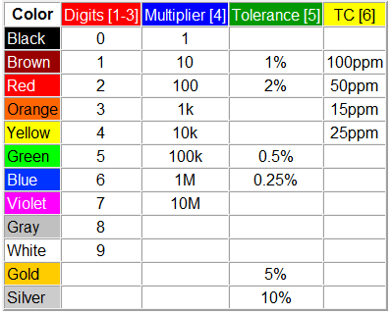

*Fig. 2.2: Resistor color code chart*

**IN-LAB:**

**LAB TASK 1:** Calculate the resistance of the resistors provided to you. Next, measure the resistance of the resistors using a multi-meter and record your values in the table below.

*Table 2.1: Lab task 1*

|  |  |  |  |  |  |  |
| --- | --- | --- | --- | --- | --- | --- |
| S:no | Resistor Color Band | Coded  Resistance  ( ) | Tolerance  (%) | Maximum  Coded  Resistance  ( ) | Minimum  Coded  Resistance  ( ) | Measured  Resistance  ( ) |
|  | Red-Violet-Orange-Silver | 27K | ±10% | 29.7K | 24.3K | 25.1K |
| 111 | Brown-red-red-gold | 1200 | +-5% | 1260 | 1140 | No need to fill this column as said by madam sidra |
| 222 | Red-red-red-silver | 2200 | +-10% | 2420 | 1980 |  |
| 333 | Green-brown-red-gold | 5100 | +-5% | 5355 | 4845 |  |
| 444 | Red-green-black-silver | 25 | +-10% | 27.5 | 22.5 |  |
| 555 | Yellow-green-yellow-silver | 450k | +-10% | 49.5k | 405k |  |
| R 6 | Red-violet-orange-gold | 27k | +-5% | 28.35k | 25.65k |  |
| 677 | Brown-green-red-gold | 1500 | +-5% | 1575 | 1425 |  |
| 899 | Violet-red-brown-green | 720 | +-0.5% | 723.6 | 716.4 |  |
| 1 10 | Green-Green-yellow-silver | 550k | +-10% | 605k | 495k |  |

Name: __________________

Enrollment #: _____________

**POST-LAB ASSIGNMENT# 2**

1. What does the tolerance band of the color code imprinted on a resistor indicate?

ANS)

It indicates how much more or less you can expect a resistor’s actual measured resistance

To be from it ’s stated resistance. ___________________________________________________________________________

1. What is the resistance of the resistor shown below? The color bands from left to right are brown, black, red and silver.

1000 %10

_________________________________________________________________________________

1. What is the resistance of the resistor shown below? The color bands from left to right are brown, black, green and gold.

1000K %5